**FINAL LAB**

**“SMOKE DETECTION AND FIRE PREVENTION NETWORK”**

**NAME: HABIBA FAYYAZ**

**ROLL #: EL-19021**

**SECTION: A**

In this project i have implemented smoke detection and fire prevention network. Whenever smoke detector will detect fire different components will react to it differently. We have used home gateway which connects LAN to WaN or it can be used to connect directly with internet.

Setting the SSID as HomeGateway of all connected devices

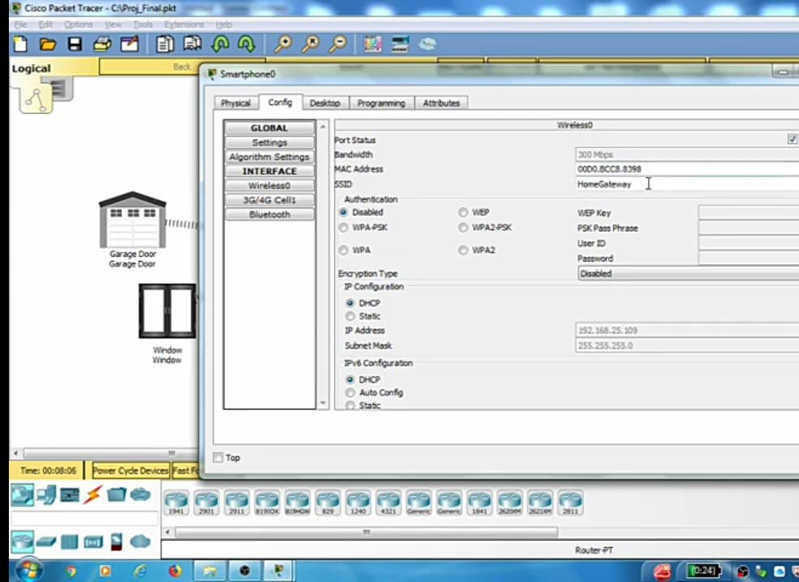

All ip addresses are assigned dynamically using DHCP.

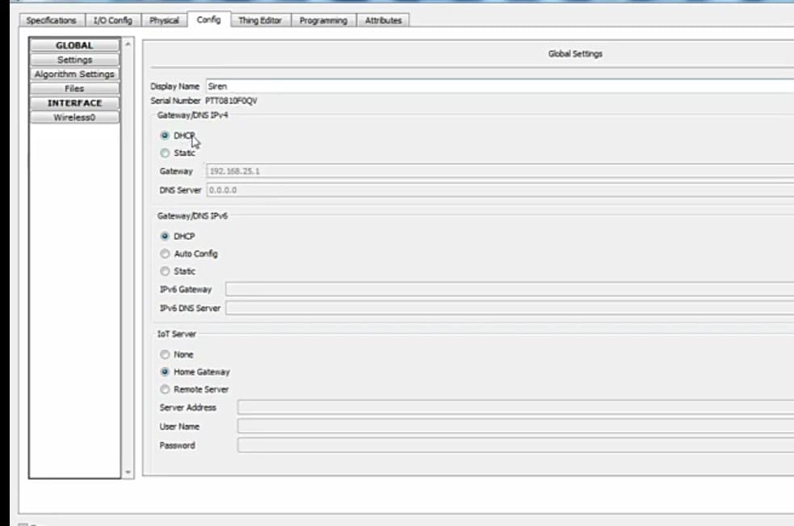

We have also connected PT-IOT-NM-1W network adaptor, which provides wireless communication.

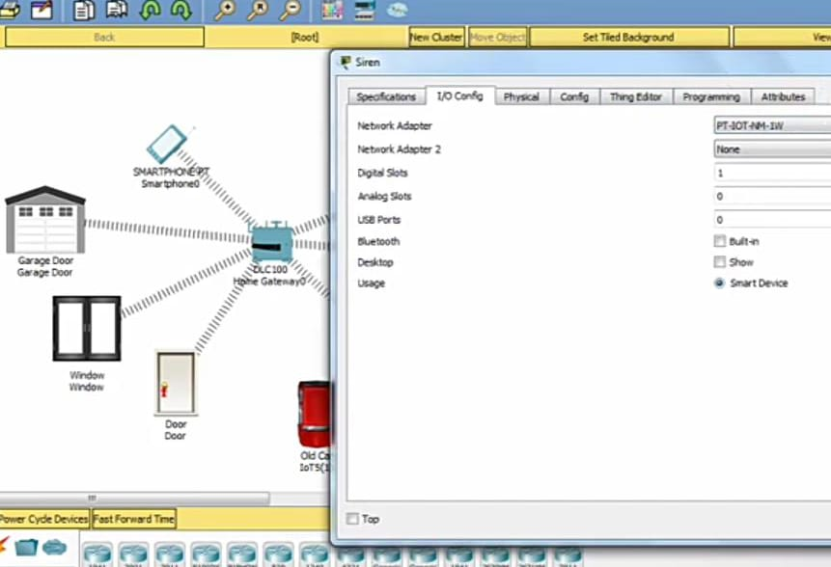

Three cars will generate smoke, There is a door which will open in case of fire alarm , Window which will open to reduce carbondioxide, garage door will also open, and fire sprinkler which minimizes the fire until fire brigade arrives.

Turning the smoke ON

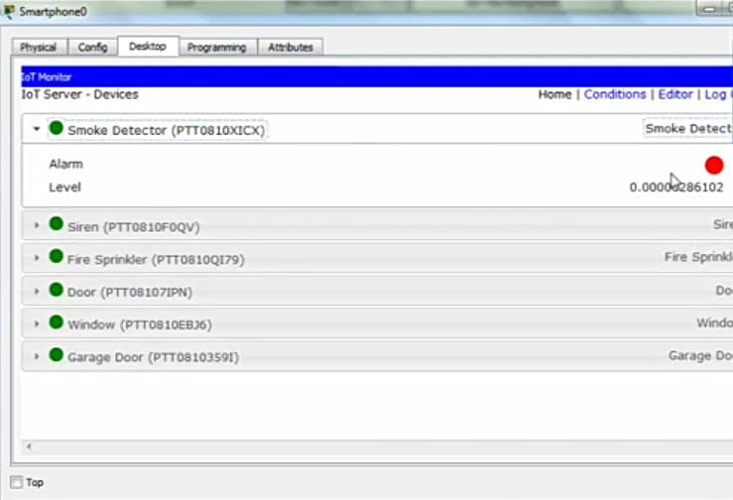

When smoke will turn ON, these conditions will apply

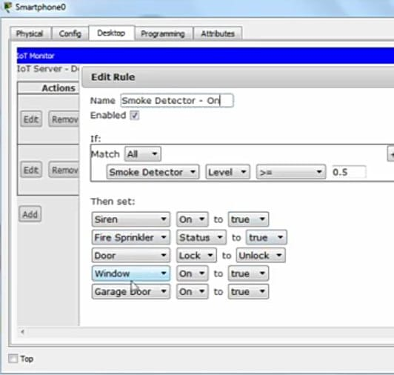

The output

